**Project Design Phase-II**

**Data Flow Diagram & User Stories**

|  |  |
| --- | --- |
| Date | 22 June 2025 |
| Team ID | LTVIP2025TMID41886 |
| Project Name | TrafficTelligence: Advanced Traffic Volume Estimation with Machine Learning |
| Maximum Marks | 4 Marks |

**Data Flow Diagrams:**

A Data Flow Diagram (DFD) is a traditional visual representation of the information flows within a system. A neat and clear DFD can depict the right amount of the system requirement graphically. It shows how data enters and leaves the system, what changes the information, and where data is stored.



**Example:** [**(Simplified)**](https://developer.ibm.com/patterns/visualize-unstructured-text/)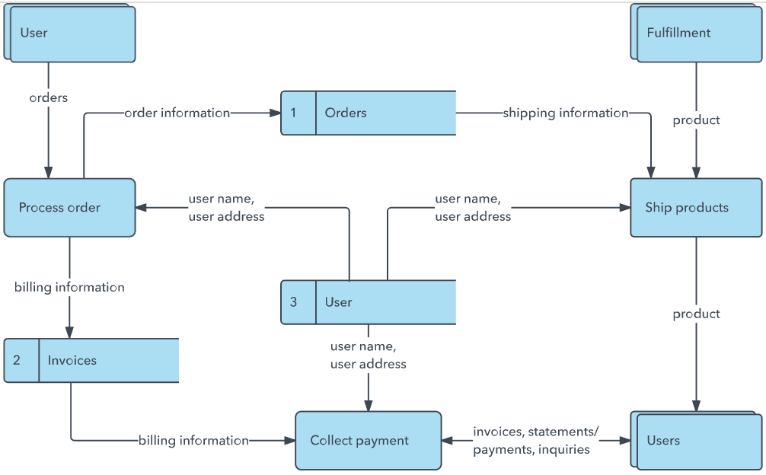

**User Stories**

Use the below template to list all the user stories for the product.

| **User Type** | **Functional Requirement (Epic)** | **User Story Number** | **User Story / Task** | **Acceptance criteria** | **Priority** | **Release** |
| --- | --- | --- | --- | --- | --- | --- |
| Customer (Mobile user) | Registration | USN-1 | As a user, I can register for the application by entering my email, password, and confirming my password. | I can access my account / dashboard | High | Sprint-1 |
| Customer (Mobile user) | Registration | USN-2 | As a user, I will receive confirmation email once I have registered for the application | I can receive confirmation email & click confirm | High | Sprint-1 |
| Customer (Mobile user) | Registration | USN-3 | As a user, I can register for the application through Facebook | I can register & access the dashboard with Facebook Login | Low | Sprint-2 |
| Customer (Mobile user) | Registration | USN-4 | As a user, I can register for the application through Gmail | I can register & login with Gmail | Medium | Sprint-1 |
| Customer (Mobile user) | Login | USN-5 | As a user, I can log into the application by entering email & password | I can access the application after login | High | Sprint-1 |
| Customer (Web user) | Dashboard | USN-6 | As a user, I can view traffic volume prediction results after uploading data | I can see charts, predictions, and accuracy | High | Sprint-2 |
| Administrator | Admin Panel | USN-7 | As an admin, I can view all uploaded files and prediction logs. | I can manage and monitor system usage | Medium | Sprint-2 |
| Customer care executive | Support & feedback | USN-8 | As a supporter staff, I can receive and view feedback or support queries from users. | I can respond to customer queries | Low | Sprint-3 |